Saudi Vision 2030 Project Dashboard Report

# 1. Objectives of the Project

The primary objective of this project is to design and develop an interactive Tableau dashboard to monitor, evaluate, and analyze the progress of key initiatives under Saudi Arabia's Vision 2030. The dashboard aims to provide stakeholders with real-time insights into project performance, financial utilization, risk management, and portfolio distribution, enabling data-driven decision-making and ensuring alignment with national strategic goals.

# 2. Problem Statement

Managing multiple large-scale projects across diverse sectors and regions presents challenges in tracking performance, budget utilization, and risk exposure. Existing reporting processes often involve manual data consolidation, which can lead to delays, data inconsistencies, and a lack of actionable insights. This project addresses the need for a centralized, visually-driven reporting system that enables timely monitoring and better governance of Vision 2030 projects.

# 3. Information About the Dataset

The dataset comprises five interconnected tables containing detailed information on projects, milestones, financial performance, risks and issues, and responsible agencies:  
- projects: Contains core details about each project, including sector, region, budget, progress, and risks.  
- milestones: Key project milestones with planned, forecasted, and actual completion dates.  
- finance monthly: Monthly planned vs. actual expenditure and earned value metrics.  
- issuesrisks: Detailed records of project issues and risks, including severity, category, and owner.  
- agencies: Agency-level performance metrics including customer satisfaction, efficiency, and digital maturity.

# 4. Data Cleaning Process (Power Query)

The dataset underwent a comprehensive cleaning and transformation process using Power Query before being imported into Tableau:  
1. Removed duplicate records across all tables.  
2. Standardized column names and data types.  
3. Handled missing values by applying appropriate imputation or exclusion methods.  
4. Created relationships between tables using unique identifiers (ProjectID, AgencyID).  
5. Converted date columns to proper date formats for time-based analysis.  
6. Derived calculated fields for KPIs such as progress percentage, budget utilization, and risk rating.

# Performance Insights

KPI Summary – Project Portfolio

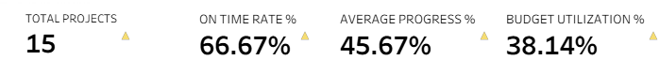

Insight: This chart shows the overall health of our projects. Out of 15 total projects, 66.67% are on time. This means two-thirds of the projects are performing well in terms of schedule, but one-third need attention. The average progress across all projects is 45.67%, which means most are halfway through their planned work. Budget utilization is at 38.14%, showing that there is still a lot of budget left to spend. This is fine if projects are on track, but if delayed, it could lead to a rush to spend later.

Projects by Sector and Status

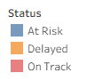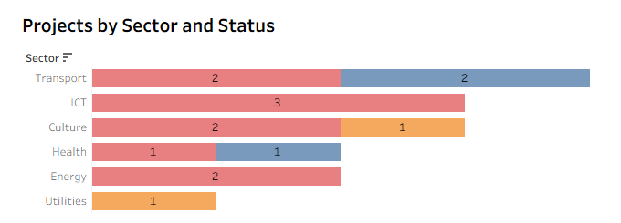

Insight: This chart groups projects by their sector and shows their status – on track, at risk, or delayed. The Transport sector has an equal split, with 2 projects on track and 2 at risk. ICT has 3 projects, all at risk. Culture has 2 at risk and 1 delayed. Health has 1 at risk and 1 on track. Energy has 2 at risk, and the Utilities sector has only 1 delayed project. This shows that most sectors have significant risk levels, with ICT and Energy needing immediate attention.

Projects by Region and Average Progress

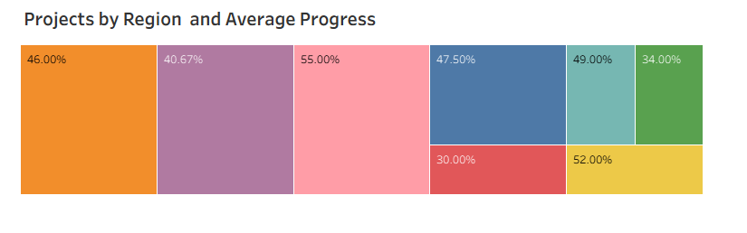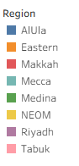

Insight: This chart shows the average project progress percentage for each region. Tabuk has the highest progress at 55%, followed by NEOM at 52%, Mecca at 49%, and AlUla at 47.5%. Eastern stands at 46%, Riyadh at 40.67%, Medina at 34%, and Makkah has the lowest at 30%. This comparison highlights strong performers like Tabuk and NEOM, while also pointing out regions such as Makkah and Medina that may need additional resources, closer monitoring, or targeted interventions to speed up progress.

KPI Summary – Financial Performance

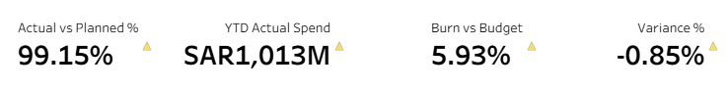

Insight: This set of key numbers gives us the financial picture. Actual spending is 99.15% of the planned budget, which means spending is closely following the plan. The Year-To-Date actual spend is SAR 1,013 million, which is 5.93% of the total allocated budget. The variance is -0.85%, meaning we have spent slightly less than planned. This can be good if work is still on track, but if work is behind, it may signal delays.

Monthly Actual vs Planned Spend

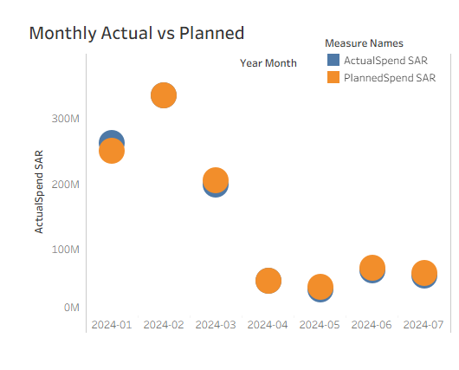

Insight: This chart compares monthly planned spending with what was actually spent. For the first three months, actual spending matched closely with the plan. From April onwards, both planned and actual spending dropped. This could mean that projects finished certain phases and were waiting for the next phase to start, or delays in approvals or supplies. Lower spending for too many months can lead to pressure later to catch up.

Budget Allocation by Vision Pillar

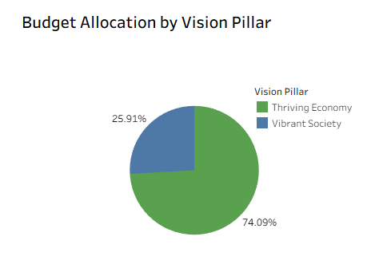

Insight: This pie chart shows how the total budget is divided between the main Vision 2030 pillars. Thriving Economy gets 74.09% of the budget, showing the priority on economic growth and infrastructure. Vibrant Society gets 25.91%, showing an important but smaller share for cultural, social, and community-focused projects. This breakdown helps us understand where resources are being directed.

YTD Actual vs YTD Planned with Variance

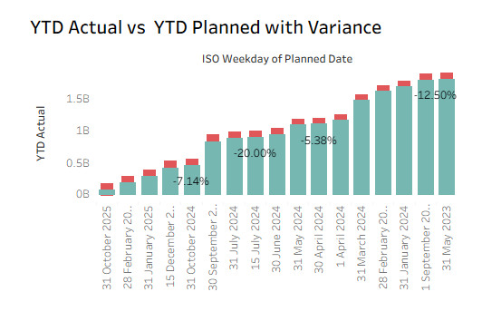

Insight: This chart shows how much we have spent so far this year compared to what we planned, along with the difference (variance). Negative percentages, like -20% or -12.5%, mean we spent less than planned at that point in time. Spending less can be fine if progress is still on schedule, but it can also mean delays that might cause rushed work later.

Project-wise CPI and SPI

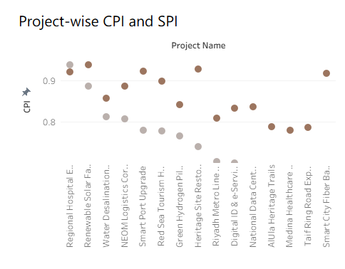

Insight: This chart shows cost and schedule performance for each project. CPI (Cost Performance Index) above 1 means the project is under budget, while below 1 means over budget. SPI (Schedule Performance Index) above 1 means the project is ahead of schedule, while below 1 means it is behind. In this chart, some projects are doing well with CPI and SPI close to or above 1, but others are struggling and need attention.

Risk Categorization by Impact & Likelihood

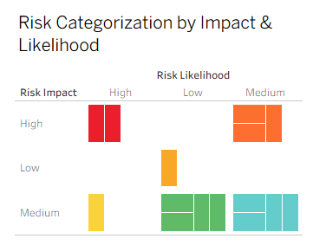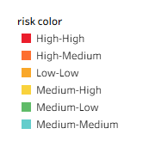

Insight: This matrix shows risks based on how likely they are to happen and how big their impact would be. Risks in the top right corner are high likelihood and high impact – these are the most urgent and need immediate action. Medium-level risks still need to be managed, but after the most urgent ones are handled. This view helps us prioritize risk management efforts.

Risk Severity by Category

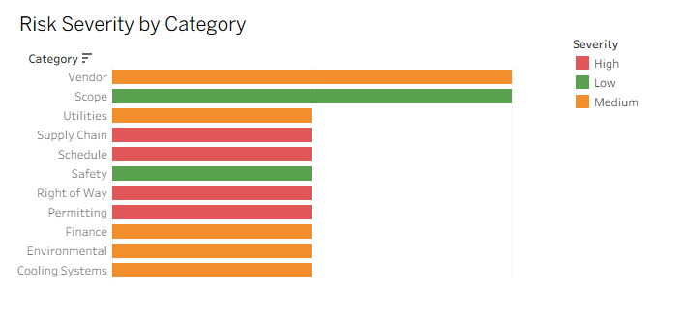

**Insights :**

**Vendor** and **Scope** categories have a **mix of Medium and Low risks**, which means they are being monitored but are not currently critical

Categories such as **Utilities**, **Finance**, **Environmental**, and **Cooling Systems** have **Medium risks**, suggesting moderate challenges in these areas.

**Supply Chain**, **Schedule**, **Right of Way**, and **Permitting** show **High risks** — these areas are the most critical and could cause major delays or cost overruns if unresolved.

**Safety** has **Low risks**, which is a good sign — but safety risks must still be watched closely to maintain compliance and avoid incidents.

# 6. Recommendations

Based on the analysis and insights from the dashboard, the following recommendations are proposed:  
1. Prioritize projects with high risk impact and likelihood for immediate intervention.  
2. Optimize budget allocation by redirecting funds from underutilized sectors to high-performing initiatives.  
3. Implement stricter monitoring of delayed projects to improve the on-time completion rate.  
4. Enhance agency performance through targeted training and process improvements.  
5. Maintain regular updates to the dashboard to ensure decisions are based on the latest data.